YOU’RE GONNA BOOK IT!
Expert Coaching and Seltapes by Lise and Kenton

Lise Cormier and Kenton Blythe offer a safe space for adults, teens and kids to be coached and do selftapes, with an emphasis on the whole person, and having fun! When you feel comfortable and safe, you can do your best work!

Lise offers these services in French as well.

Please refrain from wearing scents, especially perfume and cologne.

CONTACT

youregonnabookit@gmail.com

Located near St. Clair West Subway Station. Exact address disclosed upon booking.

SERVICES

Film, TV, Commercials, Theatre: acting coaching, selftapes (MP4), and Zoom auditions.

Voice - Animation, Commercials, Audiobooks: acting coaching, selftapes (MP3), and Zoom auditions.

TESTIMONIALS
“Kenton and Lise have a highly professional setup, which always makes me look great, no matter what kind of day I'm coming from. They are excellent readers and bring a fine attention to detail, while helping others with their auditions. I've been pinned for a lead in a series and booked a professional play, from self tapes I did with them. They are also lovely and generous human beings. Couldn't recommend more!” - Ilana Zackon (Riverdale [CW], Assassins Creed: Origins [Ubisoft])

“I have always had such a great experience taping with Kenton and Lise. They create such a spacious and welcoming environment, allowing me to bring my best work forward. Their professional setup has everything needed to deliver a high quality audition.” - Raylene Harewood (Harry Potter & The Cursed Child [Mirvish], Chesapeake Shores [Hallmark])

“Filming with Kenton and Lise was always a joy, and it showed up in the work. They both gave great reads, solid direction, and provided a positive environment from start to finish. I would recommend their studio to anyone who wants to, as Lise or Kenton would say, 'book this thing!” - Asante Tracy (The Love Club, Educator: Acting for TV and Voice [Seneca College])

ABOUT LISE
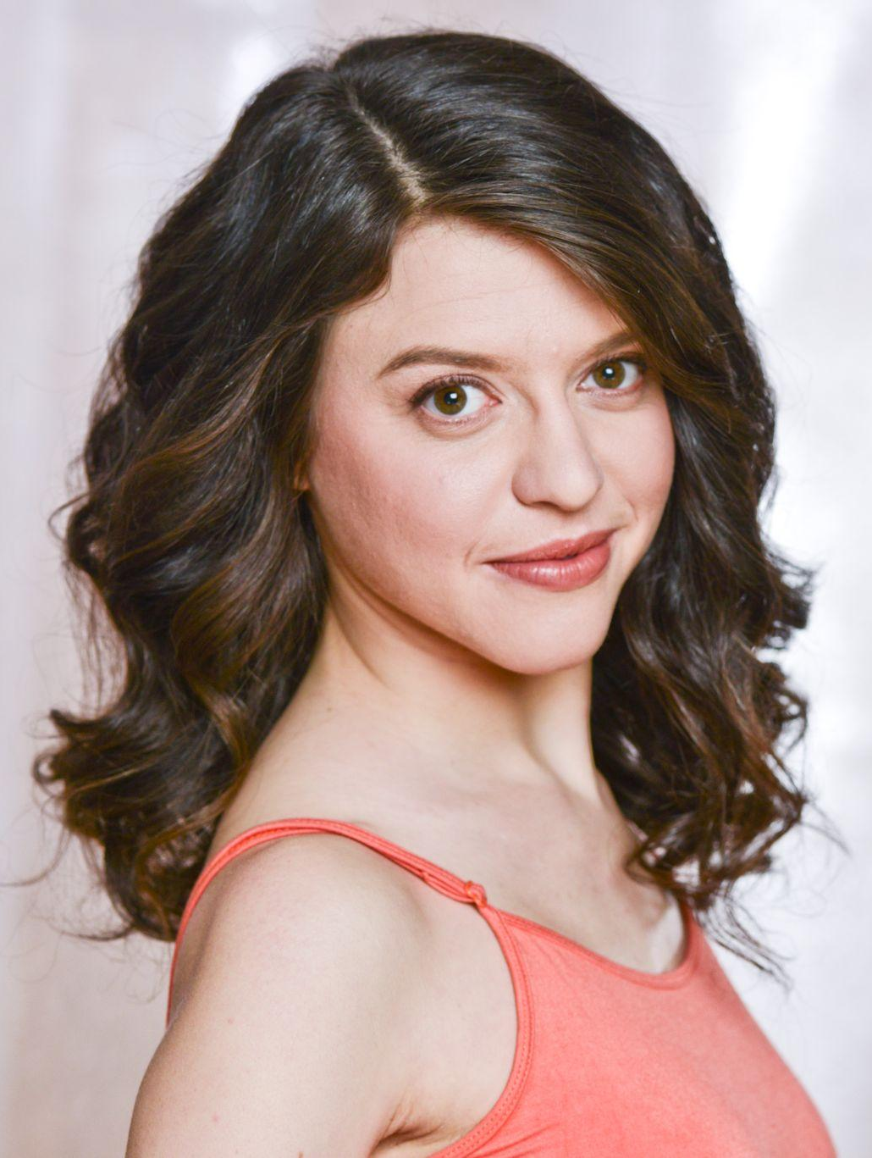
Lise Cormier is a Toronto-based bilingual actor, voice actor, singer, dancer, and writer who hails from Halifax, Nova Scotia.

Lise began to pursue a career in the arts when she was five years old, performing on stage and in the recording studio for RAZZMATAZZ FOR KIDS. She continued working throughout her childhood, and her teen credits included being a cast member at the renowned Neptune Theatre, and multiple movies of the week. After a career as a child actor, Lise continued her studies and graduated with honours from Sheridan College’s Music Theatre Performance Program, and has studied various forms of physical theatre.

She is best known for her performance as Misty Simmons in the award-winning CBC radio drama BACKBENCHER, as well as for her role as Madame Bellview in Netflix’s THE UMBRELLA ACADEMY.

She is a two time Dora Award nominee for her performances as Lise in TALE OF A T-SHIRT with Fixt Point, as well as Diablanc in ZINSPIRÉS 3D with Théâtre français de Toronto. She also played Sancho in the Dora-nominated production of THE BARBER OF SEVILLE at Soulpepper.

Lise wrote, directed and starred in the short film entitled SEXIST MICROAGGRESSIONS.

Lise has booked many commercials over the years, whether it be on camera or voice.

In both English and French, Lise has taught theatre, musical theatre, singing and dance for Studio Unio, the Toronto French School, Neptune Theatre School, Halifax Dance and the Leica Hardy School of Dance.

Lise is a proud member of the following unions: ACTRA, UDA, CAEA and SOCAN.

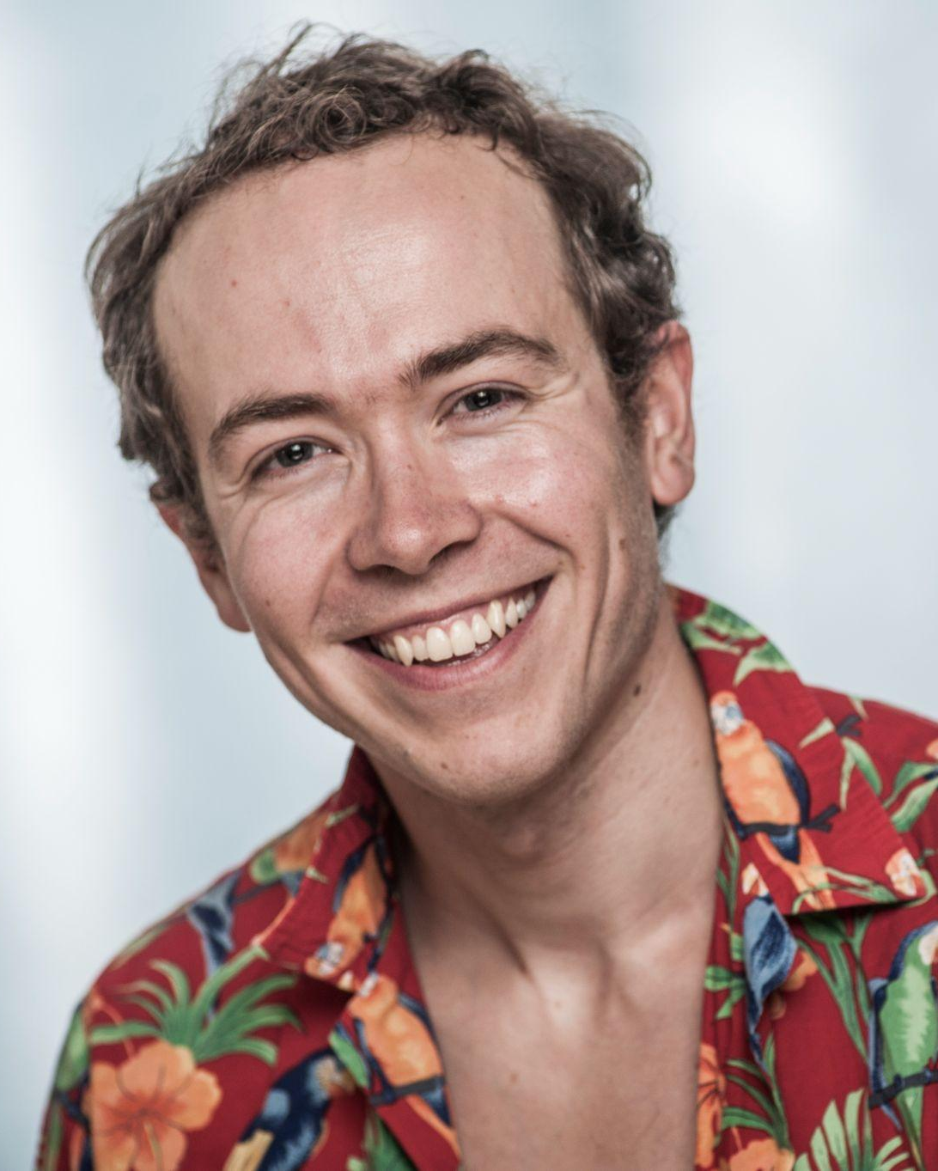
ABOUT KENTON

Kenton Blythe is an award winning Toronto-based actor, singer, musician and writer.
​
Kenton's professional stage career began after graduating from the Randolph College of Performing Arts, when he joined the international revival tour of Evil Dead: The Musical, produced by Starvox Entertainment & Jeffrey Latimier Entertainment. This critically acclaimed revival featured members of the original cast. Following the tour he became a company member of The Shaw Festival, performing in the musical Cabaret, and the play Juno and the Payock.

Kenton has been cast in several original Canadian musicals and plays, even garnering a My Entertainment World Award for Outstanding Ensemble in the new play Grey by Chantel Forde.
​
Kenton has performed in network series (Reign, Mayday), docudramas (Blood & Fury: America's Civil War), music videos, educational miniseries, comic book adaptations (Sandman: 24 Hour Diner), both Canadian and American commercials, numerous short films including his own project (Looking For Today) which received a premier at the Canadian Film Festival, and feature films (The Road to the Lemon Grove).

SERVICES / PRICES

On Camera Selftape:

Up to 30 minutes: $45 (SOC or very short scenes)
Up to 60 minutes: $75 (1-6 pages)
Up to 90 minutes: $90 (7+ pages)

~Includes: acting coaching, a reader, editing, and final tape sent to you or your agent via Wetransfer.
~Gear: tripod, lights, gray backdrop, Samsung Galaxy A50 (or your phone if preferred).
~Please email us your sides and synopsis/character breakdown the day before.

On Camera Zoom Audition:

Up to 30 minutes: $45 (SOC or very short scene)
Up to 60 minutes: $75 (1-6 pages)
Up to 90 minutes: $90 (7+ pages)

~Includes: technical assistance and acting coaching before your Zoom Audition.
~Gear: lights, gray backdrop, Logitech C920 webcam, ethernet port + cable, music stand for laptop.
~Please bring your own laptop. You can choose to plug in our webcam (specs listed above).
~Please email us your sides and synopsis/character breakdown the day before.

Voice Selftape:

Up to 30 minutes: $45 (A couple lines)
Up to 60 minutes: $75 (1-6 pages)
Up to 90 minutes: $90 (7+ pages)

~Includes coaching, editing your tape as we work, and emailing you or your agent the final MP3.
~Please bring a printed copy of your sides for you to read.
~Please email us your sides and synopsis/character breakdown the day before.
~Gear: AT2035 Microphone, Steinberg CI1 Interface, Macbook Pro, Garageband, Astin Halo, Microphone Reflection Filter, Yorkville Microphone Stand, Yorkville Music Stand, Pop Filter.

Voice Zoom Audition:

Up to 30 minutes: $45 (A couple lines)
Up to 60 minutes: $75 (1-6 pages)
Up to 90 minutes: $90 (7+ pages)

~Includes technical assistance and acting coaching before your Zoom Audition.
~Please bring a printed copy of your sides for you to read.
~Please email us your sides and synopsis/character breakdown the day before.
~Gear: AT2035 Microphone, Steinberg CI1 Interface, Macbook Pro, Garageband, Astin Halo, Microphone Reflection Filter, Yorkville Microphone Stand, Yorkville Music Stand, Pop Filter.

If you need a service not listed above, please reach out to obtain a quote.

PAYMENT
E-transfer - youregonnabookit@gmail.com or bring Cash to your session.

This space is LGBTQ+ friendly and a Transgender Safe Space. No forms of discrimination or harassment will be tolerated.

There is no elevator. Access to the space is via stairs.

Please refrain from wearing scents, especially perfume and cologne.

We look forward to seeing you soon!

YOU’RE GONNA BOOK IT!
Expert Coaching and Seltapes by Lise and Kenton

